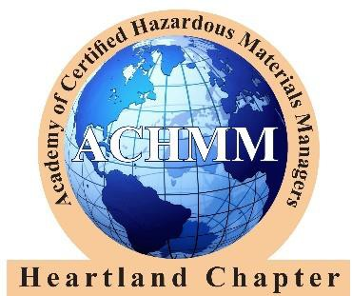

2023-24 Scholarship Application

Name: |  |  |  |  |  |  |  |  |  | Date:
CHMM Heartland Chapter Member:
Relationship to Member:
Home (summer) Address:
Phone: |  |  |  |  |  |  | Email:
School Name: |  |  |  |  |  |  |  |  |  |  | Year in School
GPA: |  |  |  | College Major or Planned Major:

Note: Please include only the most recent information, i.e. high school activities if you are graduating from high school or only college activities if you are currently in college. Add rows if needed.

- Activities and Honors (in-school):

Activity | Description | Time Spent on Activity

Honor | Description | Date Received

- Community activities (service):

Activity | Description | Time Spent on Activity

- Essay. In your own words, please write a 500-word essay answering the following questions. Responses to each question will be scored separately and be given equal weight (Attach additional sheets):

- What are your educational and career plans?
- Identify one environmental problem that you feel needs attention. What is the problem and why?
- Explain how you think the problem should be addressed. Create an innovative solution to the problem.
- Explain how your education, career choice, or other personal activities would contribute to helping the cause you have identified.

Submit your completed application no later than Sunday, April 30, 2023 via mail or email to: Andy Savastino, CHMM
City of Kansas City, MO
414 E. 12th Street, Ste. 401
Kansas City, Missouri 64106 Phone: (816) 513-3460
Email: andy.savastino@kcmo.org

